Creating Uvalde Emergency Services District No.3

November 5th, 2024 Proposition A Frequently Asked Questions (FAQ)
The County Commissioners Court for Uvalde County have called for a proposition to be placed on the ballot for November 5th, 2024. If approved by voters, this proposition would authorize the creation of Uvalde County Emergency Services District No. 3 (UCESD 3) and an ad valorem tax cap authorization of $0.10/$100 property valuation.
What is an Emergency Services District?
Emergency Services Districts (ESDs) are authorized by the Texas Constitution, Article 3, Section 48-e, and Chapter 775 of the Texas Health & Safety Code. ESDs are political subdivisions of the State of Texas. They may support or provide local emergency services, including emergency medical services, emergency ambulance services, rural fire prevention and control services, and other emergency services authorized by the Texas Legislature. ESDs may collect a sales and use tax and/or property taxes to support or provide these services.
How Would an ESD Affect the Future of the local VFD’s?
If this proposition passes, a Board of five (5) ESD Commissioners would be appointed by the County Commissioners Court to directly assist in the funding and governance of the Volunteer Fire Department’s (VFD’s), working in conjunction with the VFD Boards and established Command Staff to realize the goals of the District. The local VFD’s that will be included in this ESD are Uvalde Volunteer Fire Department, Sabinal Volunteer Fire Department, Knippa Volunteer Fire Department, and Regan Wells Volunteer Fire Department.
What Does It Mean, Appointed Commissioners?
The Board of Commissioners for the proposed ESD is selected from residents and community leaders within the ESD service area. They are appointed to staggered terms of two (2) years by the County Commissioners Court and are accountable to the Commissioners Court and their voting constituents. While not elected, they are government officials and can be re-appointed or replaced as needed by the Commissioners Court.

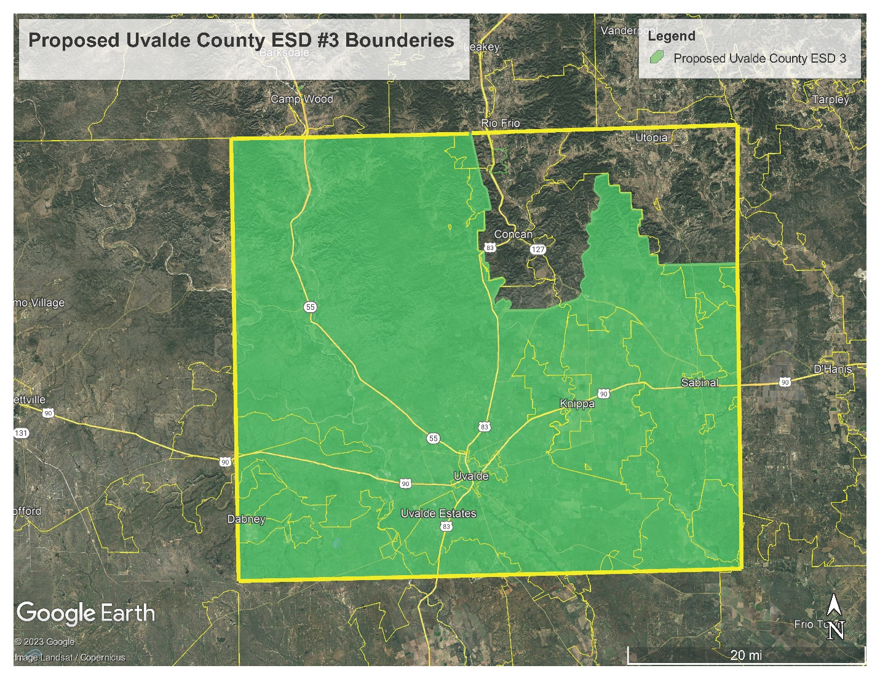

What Factors Are Facing the Local VFD’s?
Between Uvalde, Sabinal, Knippa, and Reagan Wells Volunteer Fire Department, they provide fire suppression and rescue services to an estimated 24,844 residents who live and work within the 1,323 square miles (about the area of Rhode Island) located in Uvalde County, Texas.
As the serviced areas are experiencing a period of unanticipated growth, there is more demand on the VFDs in call volume response and personnel to staff the responding apparatus. The VFD Boards are at a crossroads with funding for the department despite sound fiscal management and good stewardship. The Boards have been able to maintain the apparatus and equipment to the minimum standards needed to protect the community up through the 2024 fiscal year, but the VFDs have had to rely heavily on community contributions and fundraisers to maintain operations.
In order to regularly staff the station, maintain equipment annually and replace aging equipment in a manageable staggered progression, the VFDs will need a more robust funding model, such as the taxing authority of an ESD, to fully realize a strategic plan.

What are the Goals of the ESD, and Uvalde, Sabinal, Knippa, and Reagan Wells VFD?
The VFD’s administration and volunteer membership have been working to address the issues facing the possible ESD by developing a strategic ten (10) year funding plan. The three overarching goals outlined in the long-range plan are:

- Additional Personnel
- Expand training and retention programs to grow and maintain volunteer membership
- Purchase and maintain apparatus and equipment related to response requirements within Uvalde County

Where Do We Stand in the Process Today?
The VFDs have sent a petition, signed by more than 300 residents from the response area, to the Commissioner's court requesting a spot on the upcoming election ballot to allow the voters to decide if the area needs an ESD. On August 12, 2024 Uvalde County Commissioners Court voted unanimously to approve the request to allow the residents of Uvalde County to vote on a measure to create the Emergency Services District.

Will My Taxes Immediately Go To $0.10/$100?
The ESD, if so formed, would need to evaluate the current requirements and future goals of the VFDs, establish and adopt an annual budget and strategic plan, and then set a tax rate to meet those goals. While the proposition authorizes the levy of up to $0.10/$100, the Board of Commissioners will evaluate the best rate to move forward with. The ad valorem tax rate is evaluated and reviewed every year moving forward and can go up or down as needed to properly fund the department and any debt service but can never exceed the authorized cap of $0.10/$100.
As part of the annual review of the property tax levy, the ESD can offer exemptions such as over-65, disabled veteran, and/or homestead. While ESDs do not “freeze” ad valorem levies like Independent School Districts (ISDs) can, offering these exemptions can provide a much-needed tax relief to the elderly or those on fixed incomes.
What Will the Ballot Look Like?
The November 5, 2024 ballot will ask residents to vote for or against the creation of an Emergency Services District, and the authorization to levy an ad valorem rate not to exceed $0.10/$100 valuation.
“PROPOSITION A:
“PROPOSITION A: CONFIRMATION OF THE CREATION OF UVALDE COUNTY EMERGENCY SERVICES DISTRICT NO. 3 WHICH MAY IMPOSE AN AD VALOREM TAX RATE NOT TO EXCEED TEN $0.10/$100 AS ALLOWED BY SECTION 48-E, ARTICLE III OF THE TEXAS CONSTITUTION.”

Voters will need to be looking for this language if they wish to cast their vote regarding the proposition for UCESD 3.
Don’t the VFDs Have Paid Staff?
No. There are three (3) paid firefighters stationed at Uvalde VFD who work in 24-hr shifts. All other firefighters across the four (4) VFDs are strictly volunteer. *insert rosters*
What Happens if the Proposition Fails?
If voters do not approve the proposition creating the ESD and levying the ad valorem rate, the volunteer fire departments will continue to operate as best as it can with the funding it currently has. However, as population growth and increased call volume exceed the ability for the VFD’s to respond, residents could face diminished response quality and longer response times.
When, Where, and How Can I Vote?
WHEN:
Early Voting
October 21 – 24 8:00 am – 5:00 pm
October 26 9:00 am – 1:00 pm
October 28 – November 1 7:00 am – 7:00 pm
Election Day
November 5, 2024 7:00 am – 7:00 pm

WHERE:
Location:

HOW: Use these links to find information on the following topics:
Registering to vote: https://www.votetexas.gov/register/index.html

